SQL QUERY SYSTEM DOCUMENTATION
Conversational Data Analytics System with Multi-Turn Context & Visualization

Created By – Nuhan Gunasekara

##############################################################################

Deploying System on New Workspace
(Environment Setup)
##############################################################################

System Requirements
- **OS**: Windows 10/11, Linux (Ubuntu 20.04+), macOS 11+
- **RAM**: 8 GB minimum, 16 GB+ recommended
- **Storage**: 10 GB for models + data
- **CPU**: Modern multi-core processor
- **GPU**: Optional (speeds up Ollama if NVIDIA with CUDA)

References
- **Ollama Documentation**: https://ollama.com/docs
- **LangChain Documentation**: https://python.langchain.com/docs
- **ChromaDB Documentation**: https://docs.trychroma.com/
- **Gradio Documentation**: https://www.gradio.app/docs
- **Plotly Documentation**: https://plotly.com/python/

Install Python 3.10+
Download from python.org or use winget
```bash
winget install Python.Python.3.10
# Verify Installation
python --version
# Expected: Python 3.10.x or higher
```

Install Ollama
- Download installer from: https://ollama.com/download/windows
- Run `OllamaSetup.exe`
- Follow installation wizard
- Ollama will start automatically

To check ollama is exists
```bash
Test-Path "C:\Program Files\Ollama\ollama.exe"
```
Verify Ollama
```bash
ollama –version
```
Test Ollama API
```bash
curl -s http://localhost:11434/api/tags
```

Troubleshooting
If Ollama connection fails
Invoke-WebRequest -Uri "http://localhost:11434/api/tags" -UseBasicParsing | Select-Object -ExpandProperty Content } catch { Write-Host "Ollama not running or not accessible" }

Check if model is properly loaded
curl http://localhost:11434/api/tags

Restart Ollama if needed
taskkill /f /im ollama.exe
ollama serve
#ollama serve for start the ollama service

Create Virtual Environment and Install Python Dependencies
Create .venv
```bash
#Create
python -m venv .venv
#Activate
.\.venv\Scripts\Activate.ps1
```
Install requirements.txt – first, copy requirements.txt file into the project folder
```bash
pip install -r requirements.txt
```

Start Ollama Service
If it is not running already
```bash
# Start in background
ollama serve

# Verify server
curl http://localhost:11434/api/tags
```

Download Ollama model
```bash
# Main LLM model (7B parameters, ~4.7 GB)
ollama pull qwen2.5:7b
# Embedding model (~275 MB)
ollama pull nomic-embed-text
# Verify models
ollama list
```
Expected output:
NAME ID SIZE MODIFIED
qwen2.5:7b abc123def456 4.7 GB 2 hours ago
nomic-embed-text ghi789jkl012 275 MB 2 hours ago

Glossary
- **CTE**: Common Table Expression (SQL WITH clause)
- **ChromaDB**: Vector database for semantic search
- **Embeddings**: Numerical representations of text (768-dim vectors)
- **Intent**: User's goal (NEW_QUERY, RE_VISUALIZE, TRANSFORM, etc.)
- **LLM**: Large Language Model (qwen2.5:7b)
- **Ollama**: Local LLM server
- **Plotly**: Interactive charting library
- **Pydantic**: Data validation using Python type hints
- **Semantic Search**: Finding relevant data by meaning, not exact keywords
- **Temperature**: LLM randomness parameter (0.0-1.0)
- **Vector Database**: Database optimized for similarity search

##############################################################################

Initializing Databases
(SQL Database and Vector Database for Metadata)
##############################################################################

Converting Excel and CSV Files to a SQL Database.
I created excel_to_db.py script as a smart data ingestion tool that converts raw CSV and Excel files into a structured SQLite database for ease purpose.
SQLite was chosen for this architecture because it requires zero configuration. We don't need to install or configure a database server; the database is just a file that lives alongside the project.
Unlike standard importers that blindly treat everything as text or guess types poorly, this script uses a LLM to:
1. Understand the data It analyzes column names and sample values to determine the true business meaning.
2. Infer correct types It distinguishes between `INTEGER`, `REAL` (float), `DATE`, and `TEXT` with high accuracy.
3. Generate schema It creates a proper SQL table with constraints (e.g., `NOT NULL`).
4. Clean data It sanitizes column names into database-friendly `snake_case`.
5. Handle Multi-Sheet Workbooks It can process an entire Excel workbook, creating a separate table for each sheet.

Prerequisites
- Ollama running locally (`ollama serve`)
- Model pulled : `qwen2.5:7b` (or other specified model)
- Python environment with requirements installed (`pandas`, `openpyxl`, `langchain`, etc.)
Command Line Arguments
Argument | Default | Description
input_file | **Required** | Path to the source CSV or Excel file (e.g., `sales.xlsx`)
--db | "database_name.db" | Path where the SQLite database will be created
--model | "qwen2.5:7b" | The LLM used for analyzing data types
--sheets | "None" | Optional list of specific sheet names to process (Excel only)

Example Commands
Basic CSV Run
```bash
python excel_to_db.py sales_data.csv
```

Excel Workbook (All Sheets)
```bash
python excel_to_db.py financial_report.xlsx --db finance.db
```

Excel Workbook (Specific Sheets)
```bash
python excel_to_db.py financial_report.xlsx --sheets "Q1 2024" "Q2 2024"
```
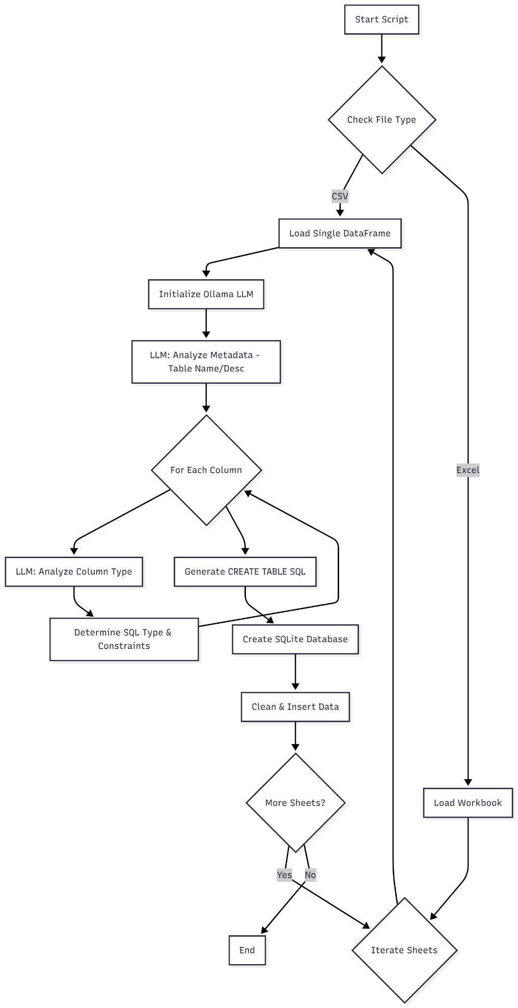
excel-to-db.py

Class & Method Reference
Class: `CSVtoDatabaseConverter`
`__init__(model, db_path)`
Initializes the LLM connection and sets up the output database path.

`convert(input_file, sheets=None)`
The main orchestration method.
1. Detects file type (CSV vs Excel).
2. Iterates through sheets (if Excel) or processes single file (if CSV).
3. Calls `_process_dataframe` for each dataset.

`analyze_metadata(df, source_label)`
Input: DataFrame and sheet name/filename.
Process: Asks LLM to suggest a table name, description, and category based on the first 5 rows.
Output: Dictionary with table metadata.

`analyze_column(column_name, column_data)`
Input: Column name and sample values.
Process: Asks LLM to determine the best SQL type (`INTEGER`, `REAL`, `DATE`, `TEXT`) and constraints.
Fallback: Uses `_auto_detect_type` (Pandas logic) if LLM fails.

`_process_dataframe(df, source_label)`
Handles the pipeline for a single table:
1. Calls `analyze_metadata` for table-level info.
2. Iterates columns and calls `analyze_column`.
3. Calls `create_database` to finalize the table creation.

`create_database(df, metadata, column_analysis)`
1. Generates a `CREATE TABLE` statement using the inferred types.
2. Sanitizes column names (e.g., "Order Date" -> `order_date`).
3. Performs type conversion on the DataFrame (e.g., string dates to datetime objects).
4. Inserts data into SQLite using `to_sql`.

Data Structures (Pydantic Models)
`MetadataResponse`
* `table_name`: Suggested snake_case name.
* `description`: Business description.
* `category`: Data category (Sales, HR, etc.).

`DataTypeResponse`
* `sql_type`: `TEXT`, `INTEGER`, `REAL`, `DATE`, `BOOLEAN`.
* `constraints`: List of SQL constraints (e.g., `NOT NULL`).
* `is_nullable`: Boolean indicating if NULLs are allowed.

Using view_analysis_db.py you can get the overview of created database.
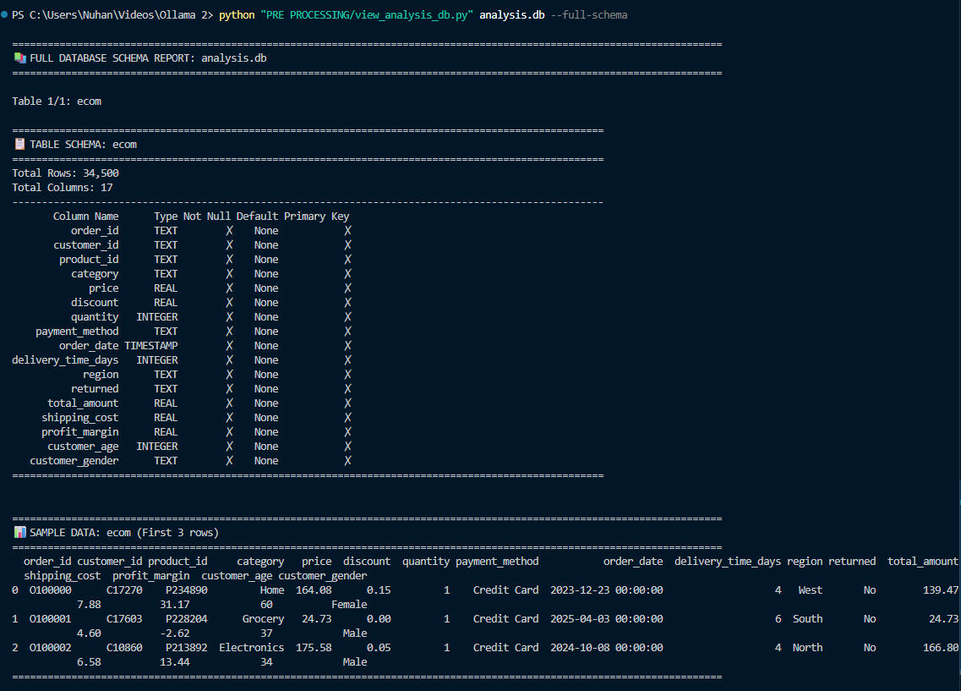

Analyzing Database to Extract Metadata
The analyze_existing_db.py script is the foundation of the semantic intelligence layer for the Conversational Data Analytics System. It performs a one-time ingestion and understanding process on an existing SQLite database.
Instead of just reading schema names (which might be cryptic like `tbl_01`), this script uses LLM to analyze representative samples of the actual data, infer business meaning, and store this knowledge in a Vector Database (ChromaDB).
Smart SQL sampling means even very large tables can be profiled without loading them fully into memory, while still giving the main application enough semantic context to answer natural-language queries like "Show me revenue" even if the table is named `transactions`.
Prerequisites
- Ollama running locally (`ollama serve`)
- Models pulled: `qwen2.5:7b` (logic) and `nomic-embed-text` (embeddings)

Command Line Arguments
Argument | Default | Description
source_db | **Required** | Path to the source SQLite database file
--vector-db | "chroma_db_768dim" | Directory where the Vector Database will be created
--model | "qwen2.5:7b" | The LLM used for analyzing data context
--embedding-model | "nomic-embed-text" | The model used for generating vector embeddings
--ollama-url | http://localhost:11434 | URL of the local Ollama server
--temperature | "0.1" | Creativity of the LLM
--chunk-size | “10000” | How many rows to pull per SQL chunk when needed
--sample-size | “1000” | Number of random rows to sample per table for LLM  context

Class & Method Reference
Class: `ExistingDatabaseAnalyzer`
This is the main controller class that orchestrates the entire process.

`__init__(...)`
Initializes connections to SQLite, Ollama, and ChromaDB. Sets up Pydantic parsers for structured LLM output and exposes `chunk_size` / `sample_size` knobs so you can control how much data is retrieved per table.

`setup_vector_database()`
Creates or loads two collections in ChromaDB:
1. `table_metadata`: Stores table-level info (description, category).
2. `column_metadata`: Stores column-level info (types, constraints, meaning).

`analyze_all_tables()`
The main entry point. Iterates through every table in the source database and calls `analyze_table()`.

`analyze_table(table_name)`
Orchestrates the analysis for a single table without loading it fully:
1. Uses SQL (`COUNT(*)`, `PRAGMA table_info`) to gather row counts and column names.
2. Pulls a random sample of up to `sample_size` rows for LLM context.
3. Calls `_analyze_table_metadata` with the lightweight sample plus the true row count.
4. Iterates through columns and calls `_analyze_column_efficient` (SQL-based stats + minimal sampling) for specific details.
5. Returns a dictionary with full analysis results.

`_analyze_table_metadata(table_name, df, total_rows)`
Input: Table name, sampled rows (DataFrame of up to `sample_size` records), and the true row count.
Process: Sends a prompt to the LLM asking it to describe the business purpose, suggest a primary key, and categorize the data based on the sample while respecting the full table size.
Output: `MetadataResponse` object (description, category, etc.).

`_analyze_column_efficient(conn, table_name, column_name, total_rows)`
Input: SQLite connection, column name, true table row count.
Process: Runs SQL aggregations (`COUNT(DISTINCT)`, `COUNT` NULLs) plus a tiny random sample (≤20 values) to brief the LLM. Only 100 values are fetched for fallback type detection, so no column is fully materialized.
Fallback: If LLM parsing fails, `_auto_detect_type` inspects the small sample to infer SQL/Python types.

`save_analysis(analysis)`
1. Constructs a rich text document for the table and each column containing all learned metadata.
2. Calls `_get_embedding()` to convert these text documents into 768-dimensional vectors.
3. Upserts (Update/Insert) these vectors and metadata into ChromaDB.

`_analyze_column(...)`
Legacy helper retained for contingency debugging. The efficient SQL path is used by default.

`_get_embedding(text)`
Sends text to Ollama's `/api/embeddings` endpoint using `nomic-embed-text`. Returns a list of floats (the vector).

def setup_prompts(self):
Prompt Engineering layer of my application. I use LangChain's PromptTemplate to create dynamic templates.
These templates combine the raw database statistics (like row counts and sample values) with strict formatting instructions.

Data Structures (Pydantic Models) - Data validation libraries
LLMs naturally output unstructured text (paragraphs). Python needs structured data (JSON) to save to a database.
These classes force the AI to format its answer exactly according to these rules. If the AI fails to provide a required field, Pydantic raises an error

`MetadataResponse` (Table Level)
* `table_name`: Name of the table.
* `description`: LLM-generated description of content.
* `suggested_primary_key`: Best guess for ID column.
* `category`: e.g., "Sales", "HR", "Inventory".
* `business_context`: How this data fits into a business.
* `data_quality_notes`: Observations about nulls or formatting.

`DataTypeResponse` (Column Level)
* `sql_type`: Recommended SQL type (INTEGER, TEXT, etc.).
* `python_type`: Equivalent Python type.
* `description`: Description of the column.
* `business_meaning`: Semantic meaning (e.g., "Revenue in USD").
* `constraints`: e.g., "NOT NULL", "UNIQUE".
* `is_nullable`: Boolean.
* `suggested_index`: Boolean.

Output Artifacts
After running, the script creates a directory (default: `chroma_db_768dim`) containing:
* `chroma.sqlite3`: The vector database index.
* UUID folders: Binary vector data.
This directory is required by the main application (`app_gradio_enhanced.py`) to function.

Error Handling
* LLM Failures: If the LLM returns malformed JSON, `_parse_with_fallback` attempts to clean the string using Regex.
* Analysis Failures: If column analysis fails completely, it falls back to Pandas type detection so the process doesn't crash.
* Connection Errors: Logs errors if Ollama or SQLite cannot be reached.

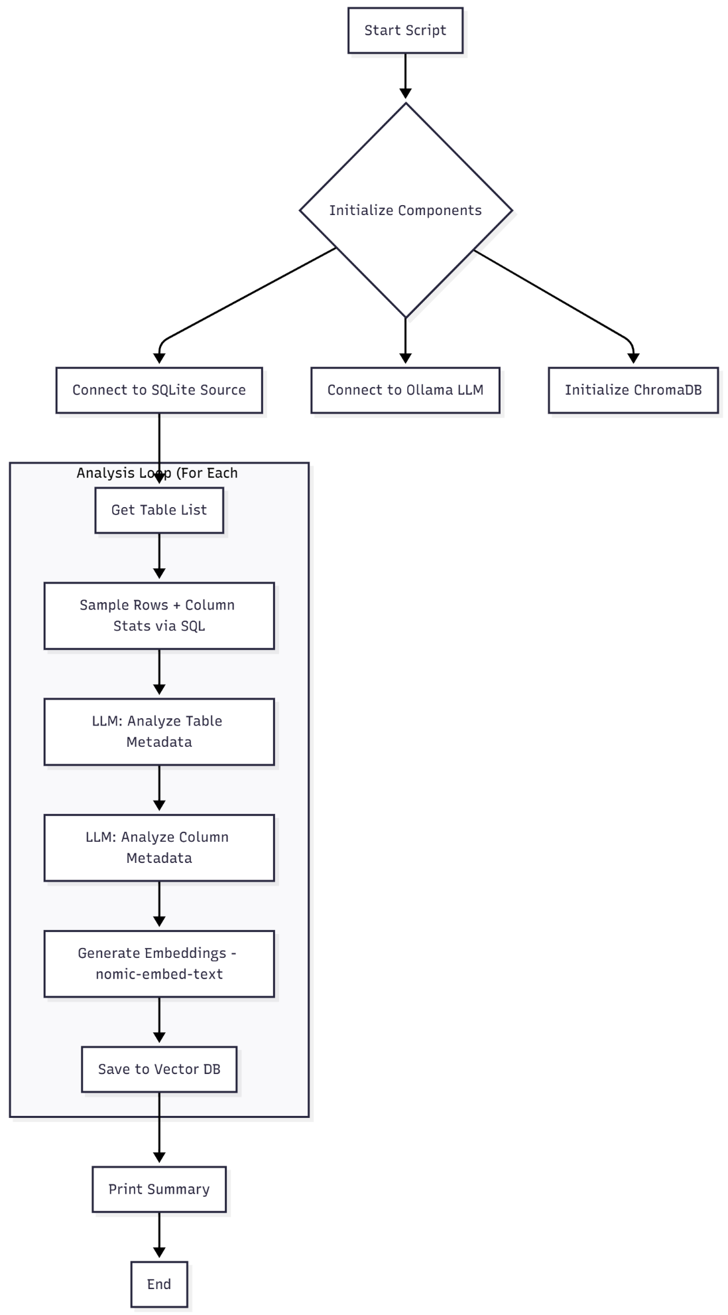
Using view_metadata.py we can see the content of created vector database.
Table Metadata
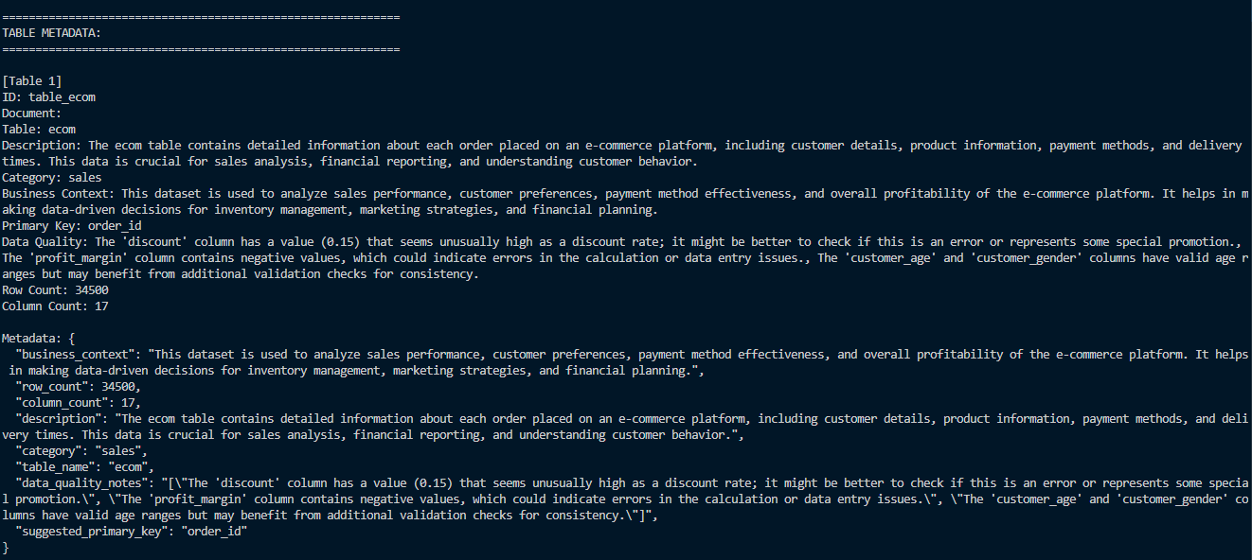
Column Metadata
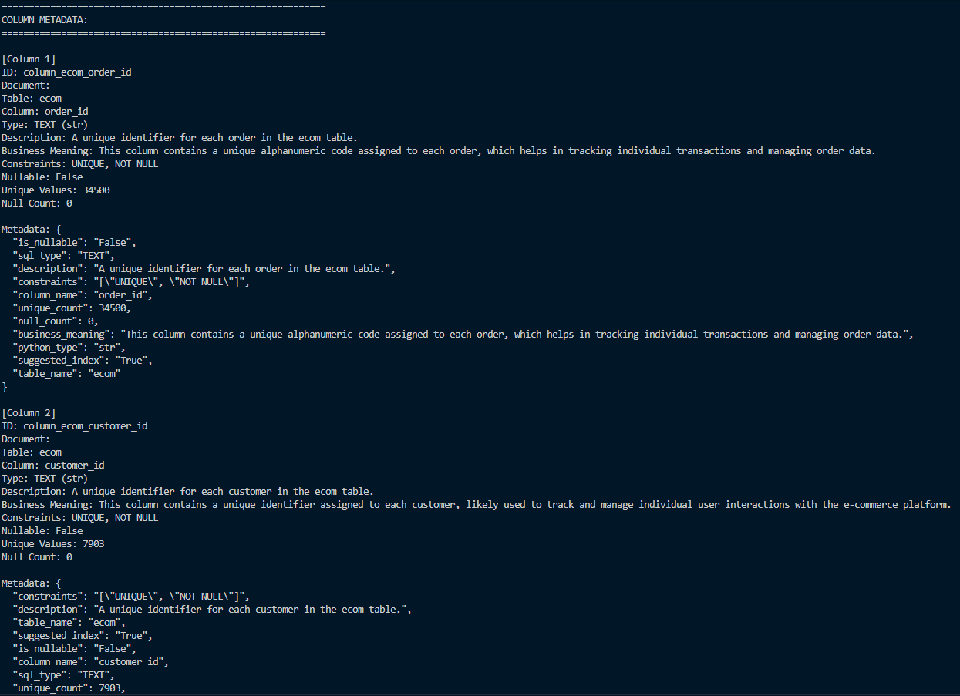
##############################################################################

System Deployment
(Query Agent + Conversation Manager + Gradio UI)
##############################################################################
Purpose
This system is a conversational data analytics platform that enables natural language querying of SQLite databases with:
- Multi-turn conversation support with full context retention
- Intelligent SQL generation using LLM (Large Language Models)
- Automatic visualization recommendation and generation
- Vector database-powered metadata retrieval for semantic search
- Persistent conversation history with ability to restore sessions
- Interactive web interface using Gradio
Key Capabilities
1. Natural Language to SQL: Convert user questions into executable SQL queries
2. Contextual Awareness: Remember previous queries and reference them in follow-up questions
3. Smart Visualization: Automatically detect when to visualize and choose appropriate chart type
4. Data Transformation: Filter, sort, and manipulate previous results without re-querying
5. Conversation Persistence: Save and restore complete conversation sessions
6. Metadata-Driven Intelligence: Use LLM-analyzed metadata for better SQL generation
Technology Stack
- **Language**: Python 3.10+
- **LLM Framework**: LangChain + Ollama (qwen2.5:7b model)
- **Vector Database**: ChromaDB (with nomic-embed-text embeddings, 768-dim)
- **SQL Database**: SQLite
- **Visualization**: Plotly (interactive charts)
- **Web Interface**: Gradio - **Data Processing**: Pandas

Prepare the Databases
Option A: Use Existing SQLite Database
Copy and paste the existing SQLite database and Vector Database (metadata) in to project folder.
Ollama /
├── app_gradio_enhanced.py # Main Gradio UI application
├── QueryAgent_Ollama_Enhanced.py # Core query processing logic
├── conversation_manager.py # Conversation state management
├── requirements.txt # Python dependencies
│
├── PRE PROCESSING/
│ ├── analyze_existing_db.py # Database analyzer
│ ├── csv_to_db.py # CSV to SQLite converter
│
├── conversations/ # Saved conversation files
│ ├── <uuid>.json
│
├── chroma_db_768dim/ # Vector database
│ ├── chroma.sqlite3
│ ├── <collection-id>/
│
└── analysis.db # User's SQLite database

Option B: From existing database or by creating SQLite database, create vector database as previously mentioned.

Launch Application
```bash
python app_gradio_enhanced.py
```
app_gradio_enhanced.py is the script created to run the UI. Gradio Library is a library which can create simple UI.
To start the system you just need to run the app_gradio_enhanced script and then select the link of the local host which is `http://localhost:6969`
You can change this later.
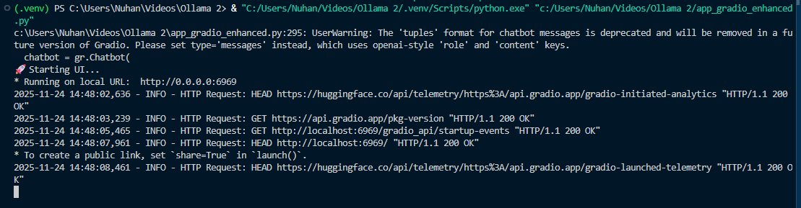
After clicking the link, the system will run on your browser as below.
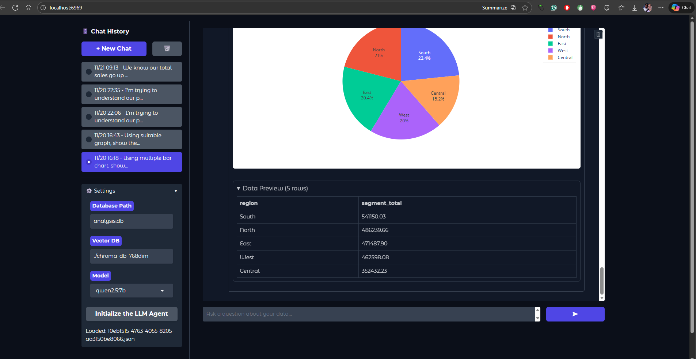

Initialize Agent in UI
If database files are in project folder, just Click the Initialize the LLM Agent button. Otherwise do the following order.
1. Enter database path: `analysis.db`
2. Enter vector DB path: `./chroma_db_768dim`
3. Select model: `qwen2.5:7b`
4. Click "Initialize the LLM Agent"
5. Wait for "✅ Agent Ready"

END-TO-END USER GUIDE - GETTING FINAL ANSWERS
Step 1: Start a New Session
1. Open the web interface at `http://localhost:6969`.
2. Click **"+ New Chat"** in the sidebar.
3. Ensure the agent is initialized (check "✅ Agent Ready").

Step 2: Ask Your First Question
Goal: Get a high-level overview.
Input: "What tables do we have in the database?"
Expected Output: A list of tables with descriptions (e.g., Sales, Products, Customers).

Step 3: Drill Down into Data
Goal: Analyze specific metrics.
Input: "Show me the total sales by product category for 2024."
Expected Output:
- A text summary of sales figures.
- A data table showing categories and amounts.
- (Optional) A bar chart if the system auto-detects the need.

Step 4: Visualize the Results
Goal: Create a chart if one wasn't generated automatically.
Input: "Visualize this as a pie chart."
Expected Output: An interactive pie chart showing the distribution of sales by category.

Step 5: Refine the Analysis
Goal: Filter or modify the data.
Input: "Filter for only Electronics and Home categories."
Expected Output: Updated text, table, and chart reflecting only the selected categories.

Step 6: Save and Share
1. The conversation is automatically saved.
2. You can return to it later via the sidebar history.
3. To share, you can export the conversation JSON file from the `conversations/` folder.

##############################################################################

Query Agent Enhanced Class
##############################################################################

System Layers
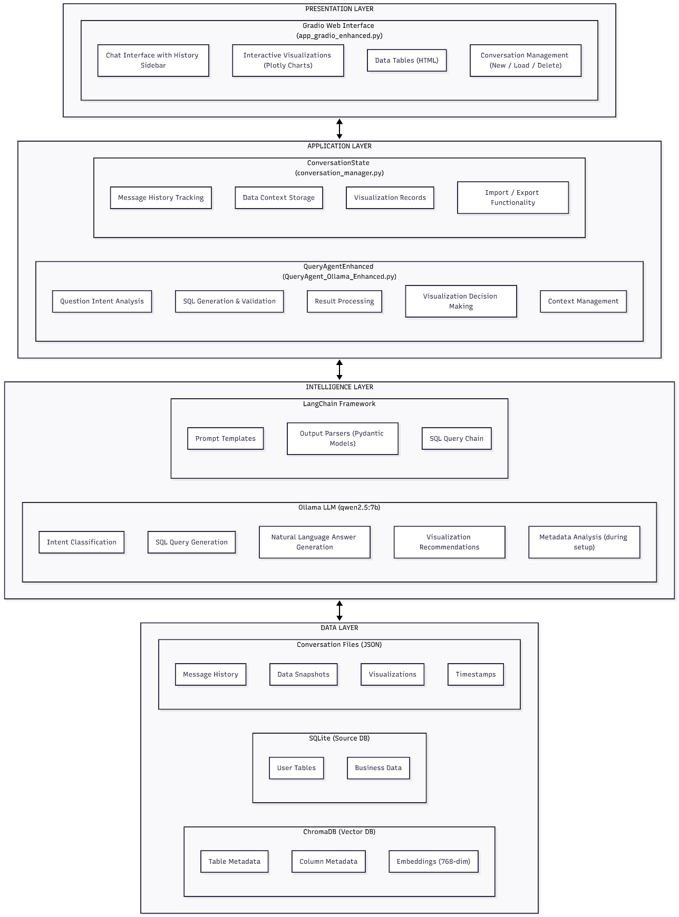

Component Interaction Flow
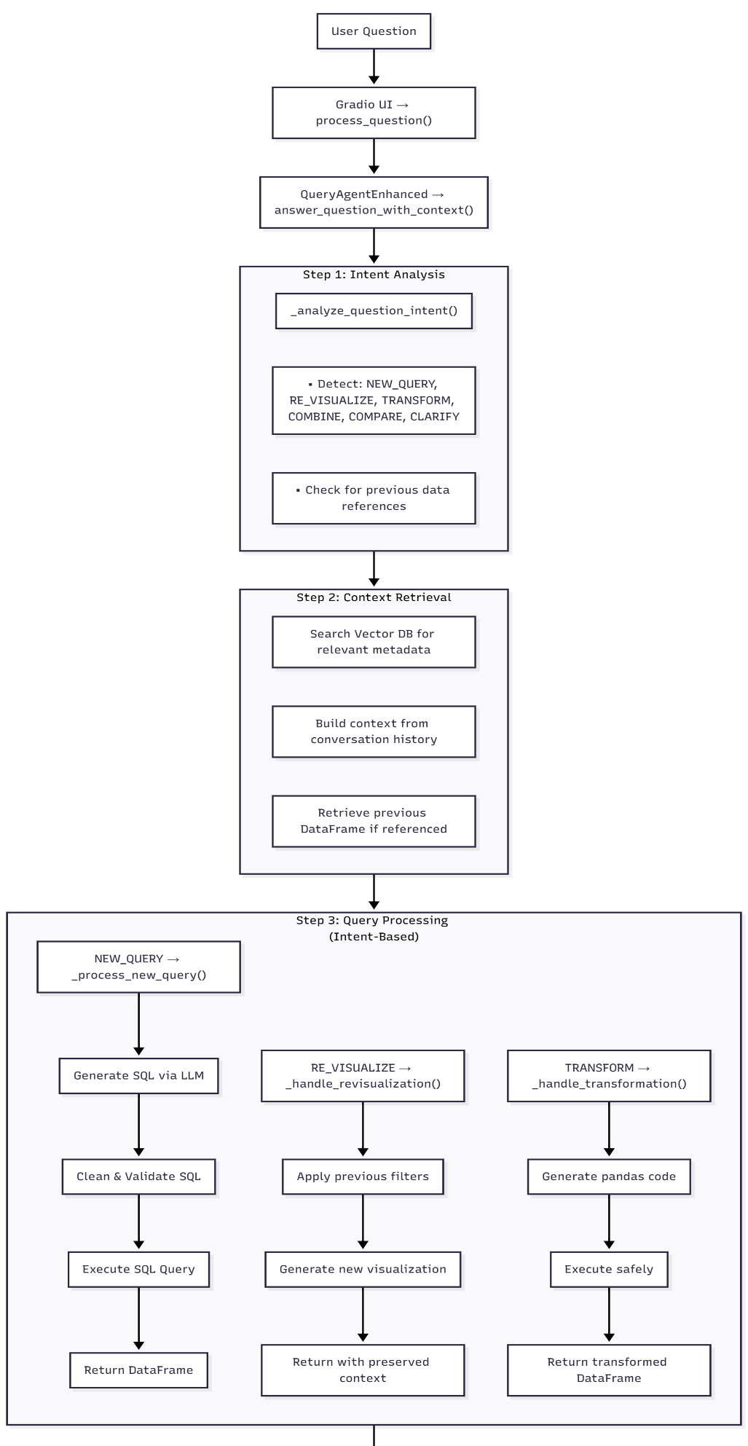

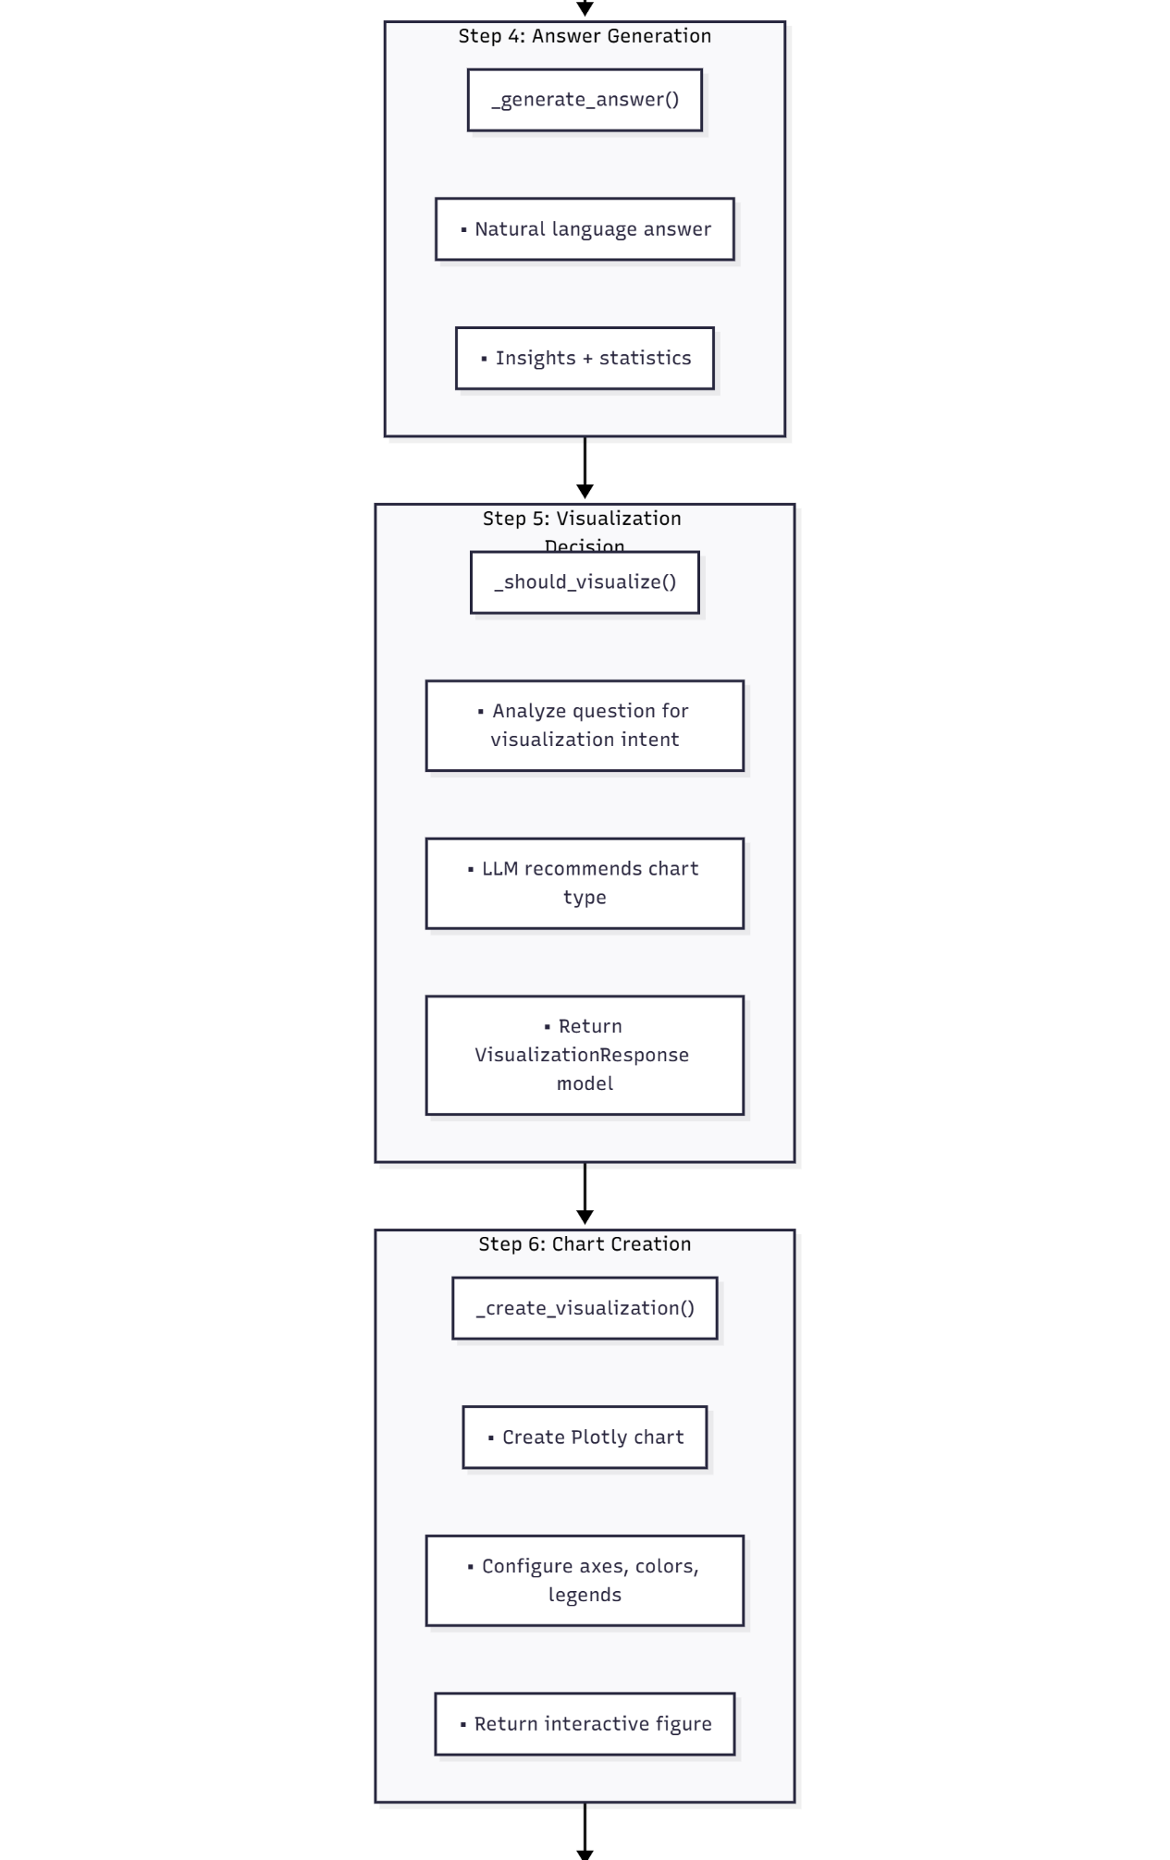
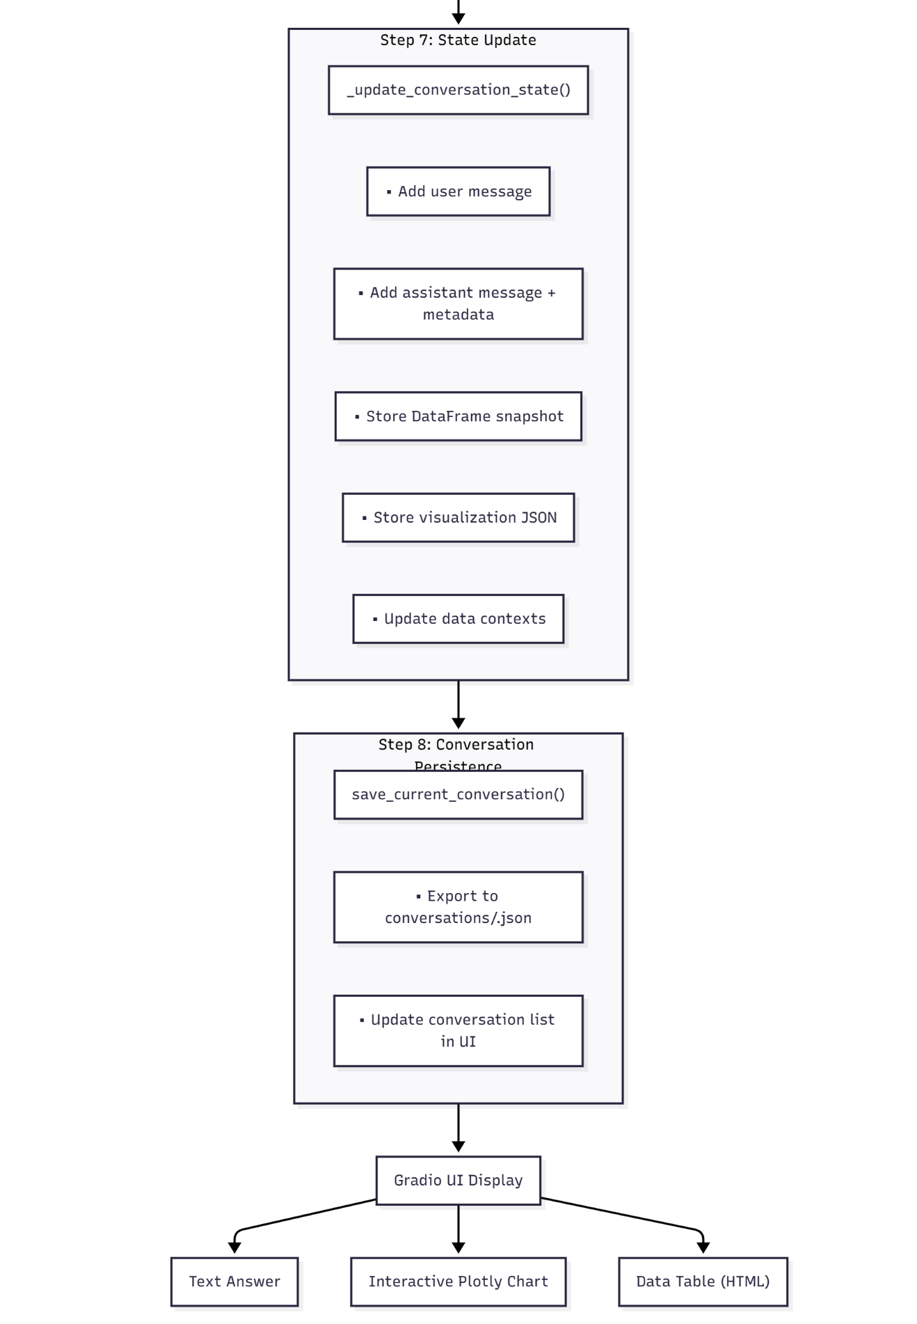

Core Components Explanation

Constructor Parameters
```python
QueryAgentEnhanced(
source_db_path: str, # Path to SQLite database
vector_db_path: str = "./chroma_db_768dim", # Path to ChromaDB
llm_model: str = "qwen2.5:7b", # Ollama model name
conversation_state: Optional[ConversationState] = None,
max_context_messages: int = 10, # Max messages to keep in context
max_data_contexts: int = 20, # Max data contexts to retain
temperature: float = 0.1, # LLM temperature (0.0-1.0)
ollama_base_url: str = "http://localhost:11434",
embedding_model: str = "nomic-embed-text" # 768-dim embeddings
)
```
Database Connection
```python
self.conn = sqlite3.connect(source_db_path, check_same_thread=False)
self.db = SQLDatabase.from_uri(f"sqlite:///{source_db_path}")
```
- Creates persistent SQLite connection
- Initializes LangChain SQLDatabase wrapper
- Allows thread-safe operations

Vector Database Setup
```python
self._setup_vector_database()
```
- Connects to ChromaDB at specified path
- Retrieves `table_metadata` and `column_metadata` collections
- Loads all metadata into memory for fast access

LLM Initialization
```python
self.llm = ChatOllama(
model=llm_model,
base_url=ollama_base_url,
temperature=temperature,
num_ctx=4096, # Context window size
num_predict=1024, # Max tokens to generate
repeat_penalty=1.1, # Prevent repetition
timeout=120 # Request timeout
)
```

Chain Creation
```python
self.query_chain = create_sql_query_chain(self.llm, self.db)
```
- Creates LangChain SQL query generation chain
- Automatically includes schema information

Parser Setup
```python
self.viz_parser = PydanticOutputParser(pydantic_object=VisualizationResponse)
```
- Initializes structured output parsers
- Ensures LLM responses match expected format

Context Awareness
`answer_question_with_context(question: str, reuse_data: bool = False) -> Dict[str, Any]`
Purpose: Main entry point for processing user questions with full context awareness.

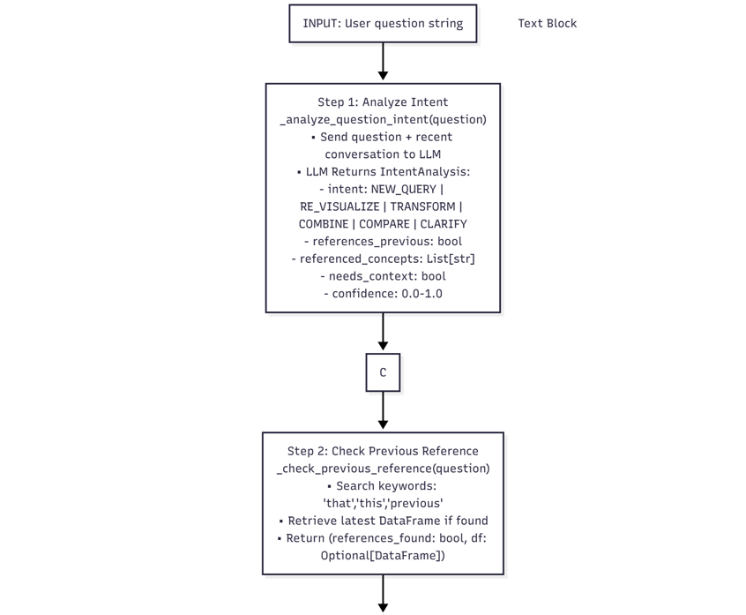
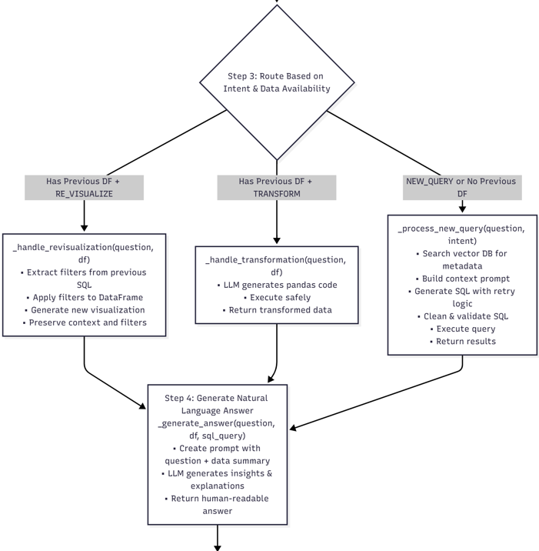

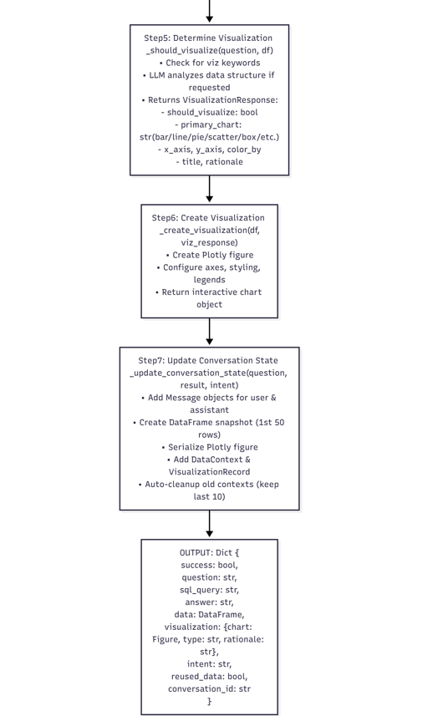

`_analyze_question_intent(question: str) -> IntentAnalysis`
Purpose: Classify user's question to determine processing strategy.
Output Example
```python
IntentAnalysis(
intent="re_visualize",
references_previous=True,
referenced_concepts=["profit margin", "categories"],
needs_context=True,
confidence=0.9)
```

`_generate_sql_with_retry(question: str, context_prompt: str, metadata_str: str, max_retries: int = 2) -> str`
Purpose: Generate SQL with automatic retry on failure.
Flowchart used for this function as below.

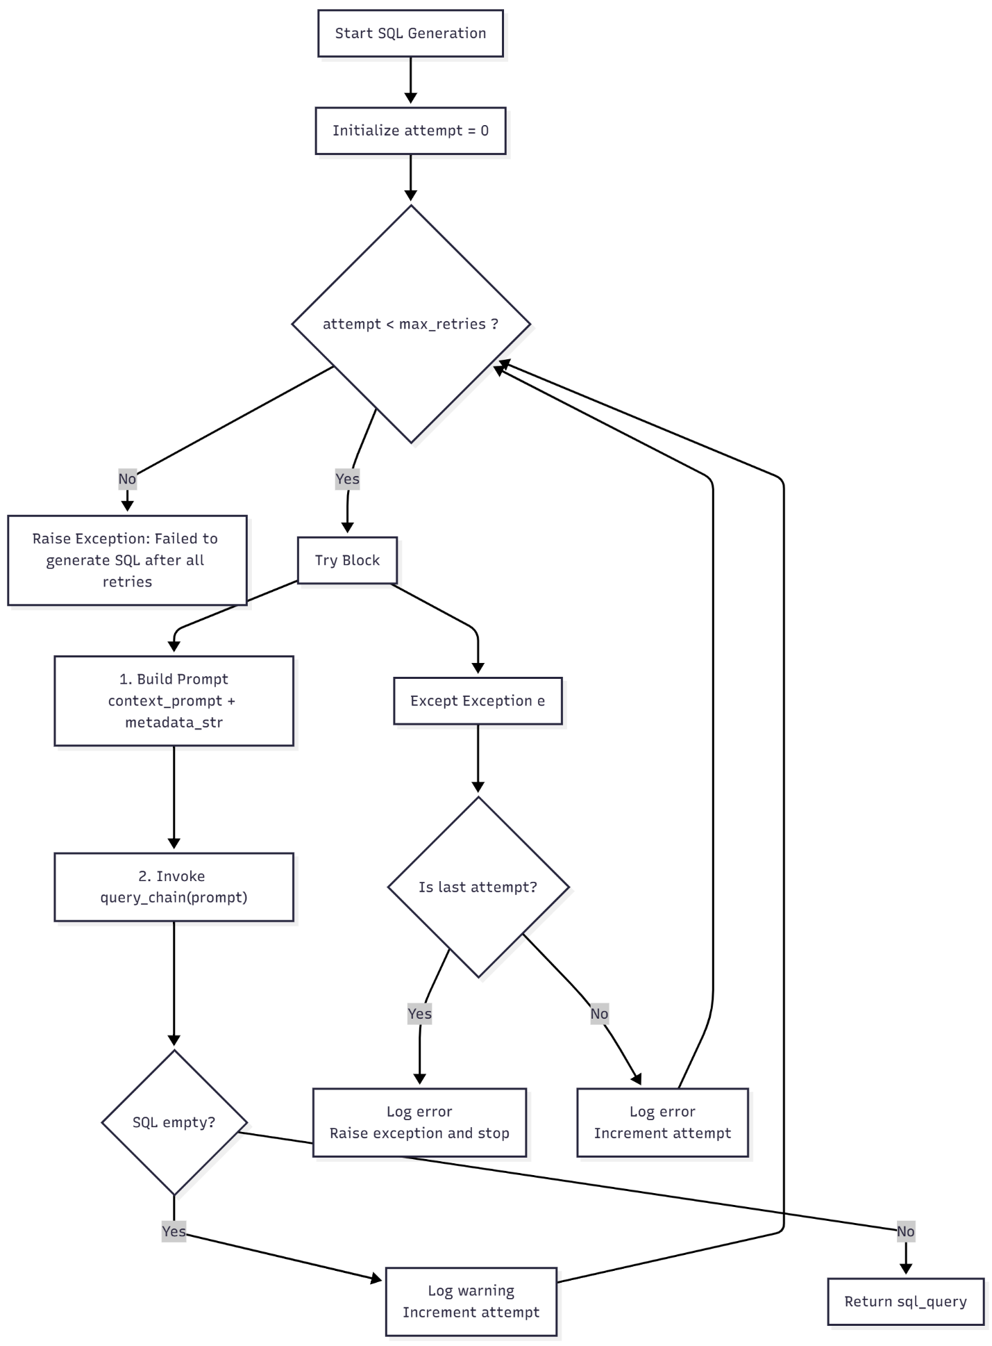
SQL Query Cleaning
`_clean_sql(query: str) -> str`
Purpose: Comprehensive SQL cleaning and sanitization.
1. Remove Markdown Fences
```python
q = re.sub(r"```\w*", "", q)
```

2. Extract Last SQL Marker
```python
marker_iter = list(re.finditer(r"(?i)(sqlquery|sql query|sql|query)\s*:", q))
```

3. Remove Explanatory Text
```python
q = re.sub(r"(?i)^.*?(?:here'?s?\s+(?:the\s+)?(?:sql\s+)?query[:\s]+)", "", q)
```

4. Extract SELECT/WITH
```python
cte_match = re.search(r"(?i)\bwith\s+[A-Za-z_][\w]*\s+as", q)
select_match = re.search(r"(?i)\bselect\b", q)
```

5. Balance Quotes
```python
single_quote_count = query.count("'")
```

6. Fix Common Syntax Issues
- Adjacent quoted strings: `AS "Total" "Sales"` → `AS "Total Sales"`
- Unquoted aliases with spaces
- Missing closing quotes in GROUP BY/ORDER BY

7. Collapse Whitespace
```python
q = re.sub(r"\s+", " ", q).strip()
```

`_validate_and_fix_tables(sql_query: str) -> str`
Purpose: Validate table/column references and fix invalid ones.

1. Get Valid Tables
- Query SQLite master table
- Extract CTE names from query
- Combine into valid_tables set

2. Build Column Map
FOR each table IN valid_tables:
- Get columns via PRAGMA table_info
- Map column_name.lower() → (table, original_column_name)

3. Analyze Query Aliases
_analyze_query_aliases(sql_query)
- Extract FROM/JOIN aliases
- Track: valid_aliases, base_to_alias, alias_to_table
4. Find Invalid JOIN Tables
- Scan for JOIN patterns
- Identify tables not in valid_tables
- Mark as invalid_tables

5. Fix Invalid References
IF invalid_tables exist:
- Remove JOIN clauses with invalid tables
- Replace invalid_table.column with valid_table.column
- Fix aggregate functions: SUM(invalid.col) → SUM(valid.col)
- Cleanup broken clauses (empty WHERE, trailing commas)

6. Fix Window Functions
- Detect SUM(alias.column) OVER ()
- Verify alias and column exist in subquery outputs
- Replace with correct column references

7. Replace Unknown Aliases
- Find all table.column references
- If table not in valid_aliases:
- Look up in base_to_alias mapping
- Replace with known alias
RETURN: Fixed SQL query

`_should_visualize(question: str, df: pd.DataFrame) -> VisualizationResponse`
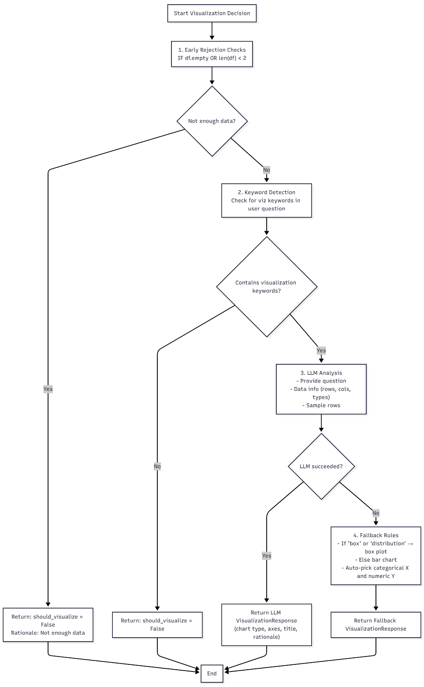
Purpose: Determine if visualization is appropriate and recommend type.

`_create_visualization(df: pd.DataFrame, viz_response: VisualizationResponse) -> go.Figure`
Purpose: Create Plotly visualization based on recommendations.
Chart Types Supported

1. Bar Chart
2. Multiple Bar Chart (Grouped)
3. Line Chart
4. Pie Chart
5. Scatter Plot
6. Histogram
7. Box Plot

